**Discussion Topic:**

Choose an open-source UML tool from the list below.  Select one of the coding weaknesses which have been identified by OWASP and create a flowchart of the steps which may have led to the weakness occurring. Which UML models might you use to present the design of your proposed software, and why are they the most appropriate choice(s)?

* [**Visual Paradigm**](https://www.visual-paradigm.com/)
* [**Sequence Diagram**](https://sequencediagram.org/%20%20)
* [**Umbrello**](https://umbrello.kde.org/)

**Answer:**

As a security risk, I have chosen Software and Data Integrity Failure, as it is quite contemporary way of performing malware activities. Moreover, the latter risk seems to be even more interesting as it includes the topics of content delivery networks and CI/CD approaches, both highly present and popular in the ´era´ of cloud computing.

Software and data integrity failures relate to the third party vendors, hence these kind of failures are in close relation with the so-called supply chain attacks. The purpose of this attack is to insert the malicious code into the system instead of hacking the network directly (Oladimeji & Kerner, 2022). Software and data integrity violations happen when the application relies upon the libraries and plugins from the untrusted resources, consequently compromising the entire system. Moreover, many contemporary devices have so-called auto-update functionality, which means that without sufficient verification, hackers are potentially able to upload their own libraries/packages and consequently install malicious software (OWASP, 2021).

I have decided to illustrate the above mentioned risks as a state transition diagram, as it appears to be the most intuitive way of presenting the precautions required in order to avoid the software integrity failures.

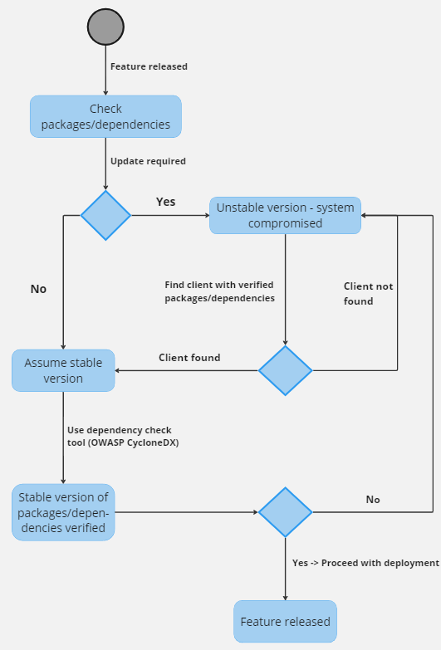

References:

Kerner, M., S., Oladimeji, S. (2022). SolarWinds hack explained: Everything you need to know. SolarWinds breach news center. Available from: https://www.techtarget.com/whatis/feature/SolarWinds-hack-explained-Everything-you-need-to-know [Accessed 7 May 2023]

OWASP (2021) 'OWASP Top Ten Project', available at: https://owasp.org/www-project-top-ten [Accessed 7 May 2023].